Branch Coverage for frontend

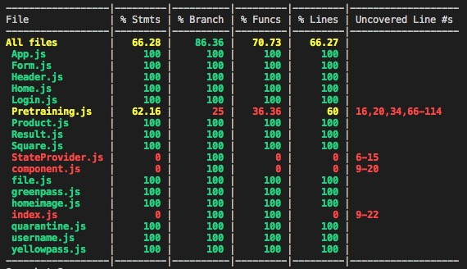Explanations for why the branch coverage is under 90%:

Because we can’t test all situations in pretraining.js file, some functions in this file we never need in frontend, which means that they don’t show on the webpage, If I comment them, there will be no difference in the front end part and the branch coverage will turn to 100%, but the backend need these functions, and I search with google how to test this part of “fake code” and get no idea.